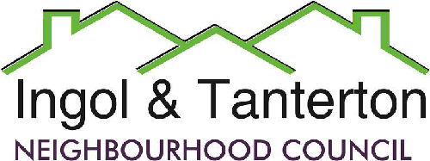
Gill Mason - Clerk and RFO
Email: ingoltantertonnc@hotmail.co.uk

Agenda
A meeting of the Ingol and Tanterton Neighbourhood Council Area Enhancement Committee will be held on Wednesday 6th March 2024 at 6pm at Tanterton Village Centre.

Open forum

1.To receive apologies.

2.To receive the update on the Ingol Dip sale / lease proposal and update from Community Gateway.

3.To receive the information from the solicitors on what is required for the purchase / lease and the next steps for the neighbourhood council.

4.To receive the potential ongoing maintenance costs for the Ingol Dip area to the neighbourhood council.

Press and public are welcome to attend.

